Lab - IP Address Subnetting 1

A network administrator for a small company has been assigned a Class C network address: 192.168.1.0 /24 (or subnet mask: 255.255.255.0).

There are a total of 3 departments in this company: Sales, Tech Support and Admin.

Sales dept has 50 staff,
Tech Support has 25 staff and
Admin has 10 staff.
PC1
PC2
PC3
Fa0/0
Fa0/2
Fa0/1
RouterA
SwitchA
SwitchB
SwitchC
Sales
Tech Support
Admin

Using Variable Length Subnet Mask (VLSM), design the IP addressing scheme to cater to the needed subnets, based on the maximum number of staff in each department.

What is VLSM?
Variable Length Subnet Mask (VLSM) is a means of allocating IP addresses according to needs rather than some general network rule. It allows an organization to use different subnet masks for the subnets created within the organization’s network address space.

Steps to do VLSM subnetting:

    - Rank the subnets from the biggest requirements to the smallest – in this case:
Sales (50) then Tech Support (25) followed by Admin (10)

    - Start the VLSM subnetting with the largest requirement. Use the formula:

No. of host = 2^{H} – 2 (where H = no. of host bits)

2^{H} – 2 ≥ host requirements
→ 2^{H} – 2 ≥ 50 (since Sales dept. need 50 hosts)

    - The subnet prefix is the number of network bits = 32 – H

    - Calculate the new subnet mask, based on new no. of network bits.

    - Calculate the new subnet addresses & list the prefix with the subnet address.

    - Assign the 1st subnet address to the 1st group and the next subnet address to the next smaller group.

    - Then repeat Steps 2 to 6 for the next requirements.

Part 1: Working for Subnet calculations

Given: 192.168.1.0 /24 → Network = 24 bits & Host = 8 bits

- Sales – requires 50 hosts (for 50 staff)

Number of Host bits required:
2^{H} – 2 ≥ 50 → 2⁶ – 2 = 64 – 2 = 62 (OK, since > 50)

No. of host bits, H = 6 bits → No. of network bits = 32 – 6 = 26

Network = 26 bits → Prefix = /26

New Subnet mask:
Original → /24 → 24 bits Network

24 bits network 8 bits host

Subnet mask: 11111111.11111111.11111111.00000000
255.255.255.0

New Network → /26 → 26 bits network

26 bits network

New Subnet mask: 11111111.11111111.11111111.11000000
255.255.255.192

Subnet calculations:
Subnet addresses:
26 bits network 6 bits host

- 11000000.10101000.00000001. 00 000000 → 192.168.1.0 /26
- 11000000.10101000.00000001. 01 000000 → 192.168.1.64 /26
- 11000000.10101000.00000001. 10 000000 → 192.168.1.128 /26
- 11000000.10101000.00000001. 11 000000 → 192.168.1.192 /26

Assign the 1st subnet, subnet 0 (192.168.1.0 /26) to the Sales dept.

Next, assign the next subnet (192.168.1.64 /26) to be used for the next requirement.

- Tech Support – requires _____ hosts.

Number of Host bits required:

2^{H} – 2 ≥ ___ →

New Subnet mask:

New Network →

Subnet calculations:
Subnet addresses:

Assign the 1st subnet, subnet 1 (_________________) to the Tech Support.

Assign the next subnet (__________________) to be used for the next requirement.

- Admin – requires _____ hosts.

Number of Host bits required:

2^{H} – 2 ≥ ___ →

New Subnet mask:

New Network →

Subnet calculations:
Subnet addresses:

Assign the 1st subnet, subnet 2 (_________________) to the Admin.

Assign the next subnet (__________________) to be used for the next requirement.

Part 2: Working for Broadcast address calculations

- Sales – 26 bits network & 6 bits host

Subnet address: 192.168.1.0 /26 (from above calculations)

In Binary: 11000000.10101000.00000001. 00 000000

Broadcast address → set all host bits to ‘1’
11000000.10101000.00000001. 00 11111 → 192.168.1.63 /26

- Tech Support – ___ bits network & __ bits host

Subnet address: ___________________ (from above calculations)

In Binary: _______________________________________

Broadcast address → set all host bits to ‘1’

_______________________________________ → ________________

- Admin – ___ bits network & __ bits host

Subnet address: ___________________ (from above calculations)

In Binary: _________________________________________

Broadcast address → set all host bits to ‘1’

_______________________________________ → ________________

Fill up the Network Address Table

Subnet Name | Subnet Address /Prefix | Usable Range | Broadcast Address
Sales (50) | 192.168.1.0 /26 | .1 to .62 | .63
Tech (25) | 192.168.1.64 /27 | .65 to .94 | .95
Admin (10) | 192.168.1.96 /28 | .97 to .110 | .111

Notes:
The Subnet Address and the Broadcast Address are the 2 IP addresses, of each subnet, that cannot be used / assigned to any host.
The 1st usable IP address is 1 more that the Subnet Address.
The last usable IP address is 1 less than the Broadcast Address.
Fill up the Addressing Table

(Note: Use the 1st usable IP address for each router’s Ethernet interface & next address for the PCs).

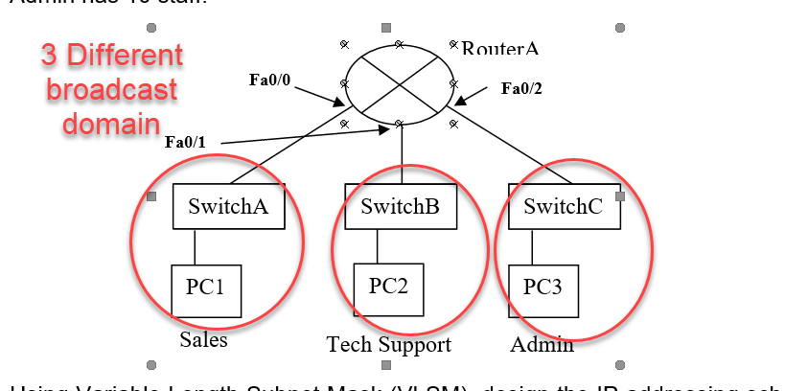

Device | Interface | IP Address | Subnet Mask | Default Gateway
RouterA | Fa0/0 | 192.168.1.1 | /26 | N/A
RouterA | Fa0/1 | 192.168.1.65 | /27 | N/A
RouterA | Fa0/2 | 192.168.1.97 | /28 | N/A
PC1 | NIC | 192.168.1.2 | /26 | 192.168.1.1
PC2 | NIC | 192.168.1.66 | /27 | 192.168.1.65
PC3 | NIC | 192.168.1.98 | /28 | 192.168.1.97

